**Assignment – II**

**Topic :** PYTHON CODE TO GET TEMPERATURE AND

HUMIDITY VALUE

**Name:** Christiya

**RegisterNumber:** 920819106011

**E-Mail Id :** christiya60@gmail.com

**Code:**

import random while(True): temp=random.randint(10,99) humidity=random.randint(10,99) print("current temperature: ",temp) print("current humidity:",humidity,"%") temp_ref=45 humidity_ref=50 if temp > temp_ref and humidity < humidity_ref: print("Alarm on") else: print("Alarm off") break **OUTPUT**

**:**

**ALARM ON**

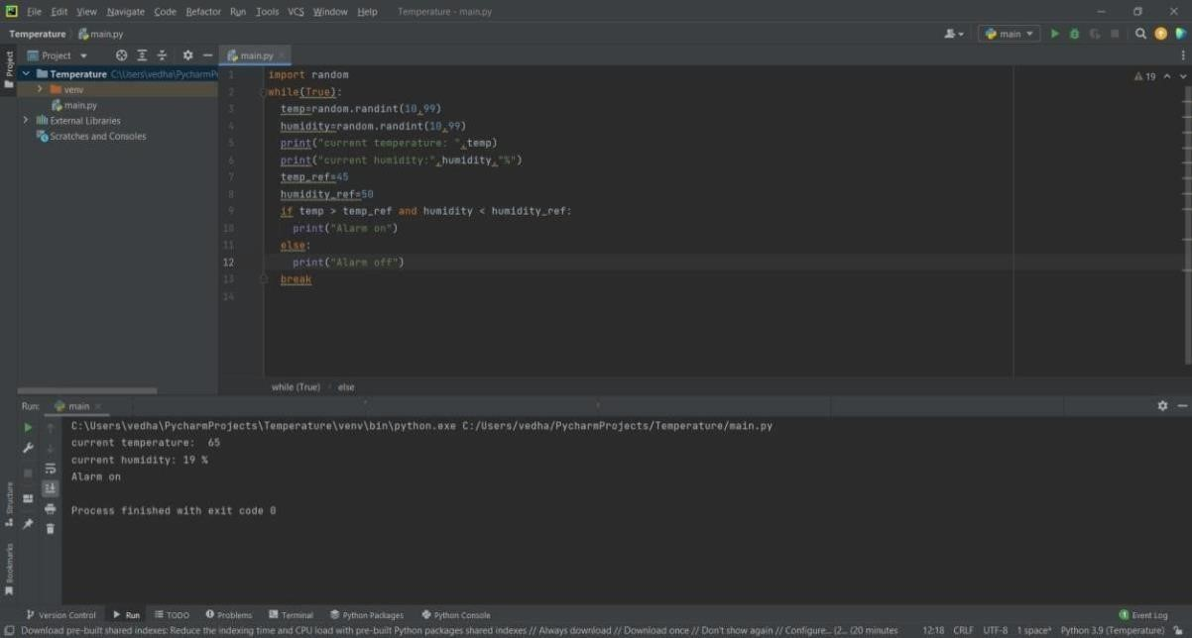

**ALARM OFF**

